**Status and Trends in the Lake Superior Fish Community, 2019**

Mark R. Vinson, Lori M. Evrard, Owen T. Gorman, Caroline L. Rosinski, Daniel L. Yule U.S. Geological Survey Great Lakes Science Center Lake Superior Biological Station

2800 Lakeshore Drive East, Ashland, Wisconsin 54806 ([mvinson@usgs.gov](mailto:mvinson@usgs.gov))

**Abstract**

The Lake Superior fish community was sampled in 2019 with daytime bottom trawls at 76 nearshore and 35 offshore stations distributed throughout the lake. In the nearshore zone, 25146 fish from 24 species or morphotypes were collected. The number of species collected at nearshore stations ranged from 0 to 15, with a mean of 5.6 and median of 5. Nearshore mean biomass was 5.7 kg/ha which was **similar to** the past twenty-year average of 5.2 kg/ha and **less than** the 42-year period-of-record mean of 8.5 kg/ha. Lake Whitefish, Rainbow Smelt, Longnose Sucker, Bloater, lean Lake Trout, Cisco, Burbot, Pygmy Whitefish had the highest total collected biomass. In the offshore zone, 13145 fish from 11 species or morphotypes were collected. The number of species collected at offshore stations ranged from 2 to 6, with a mean of 3.6 and median of 4. **Catches in this survey are dominated in both counts and biomass by Kiyi, Deepwater Sculpin, and siscowet Lake Trout.** Mean offshore biomass for all species in 2019 was 7 kg/ha which was **greater than** the period-of-record 9-year average of 6.6 kg/ha. Median biomass for all offshore species in 2019 was 5.7. Recruitment, as measured by age-1 densities were **near the period-of-record lakewide average** for Lake Whitefish (6.7 fish/ha) and Rainbow Smelt (137.1 fish/ha) and were **lower than** the period-of-record lakewide average for Bloater (3.8 fish/ha), Kiyi (0.9 fish/ha), and Cisco (0.3 fish/ha). Survival of *Coregonus* species to age-1 continues to be a major concern of fishery managers.

The data associated with this report have not received final approval by the U.S. Geological Survey (USGS) and are currently under review. The Great Lakes Science Center is committed to complying with the Office of Management and Budget data release requirements and providing the public with high quality scientific data. We plan to release all USGS research vessel data collected between 1958 and 2019 and make those publicly available. Please direct questions to our Information Technology Specialist, Scott Nelson, at [snelson@usgs.gov](mailto:snelson@usgs.gov).

**Introduction**

The U.S. Geological Survey Lake Superior Biological Station conducts annual daytime bottom trawl surveys in nearshore (~15-80 m depths) and offshore (~100-300 m depths) waters of Lake Superior. These surveys provide data for assessment of trends in species occurrence, relative abundance, and biomass for principally demersal fish. These data have historically been considered population indices rather than absolute abundance and biomass estimates. The nearshore survey has been conducted annually since 1978 in U.S. waters, and since 1989 in Canadian waters. The offshore survey has been conducted annually since 2011. The primary goal of the surveys is to report on population biomass estimates for common species and age-1 density estimates (a.k.a., recruitment index) for selected commercial and recreational species (Rainbow Smelt, Cisco, Bloater, Kiyi, Lake Whitefish, and Lake Trout, scientific names are provided in Table 1). Age and diet analyses are conducted for selected species. Fish population data in this report are based solely on bottom trawl sampling. Fishing gear bias should be considered when interpreting the results, particularly for species with lower vulnerability to daytime bottom trawls, such as adult Cisco and adult Lake Trout (Yule, et al. 2008. Factors affecting bottom trawl catches: implications for monitoring the fishes of Lake Superior. North American Journal of Fisheries Management, 28:109-122). At each fish sampling station, larval fish are sampled by surface trawling, zooplankton are sampled by a whole water column (up to 100 m) vertical zooplankton tow, and an electronic water profiler is deployed that collects data on depth, water temperature, specific conductance, pH, dissolved oxygen, chlorophyll a, photosynthetic active radiation (PAR), and beam transmission. Herein we report on bottom trawl fish and water temperatures collected during the survey.

**Methods**

**Nearshore survey bottom trawling**

Nearshore sites are located around the perimeter of the lake. In 2019, 76 of 78 planned long-term sites were sampled between **29 May and 22 June** (Figure 1). At each location, a single bottom trawl tow was conducted with a 12-m Yankee bottom trawl with either a chain or 6-inch rubber roller foot rope. The roller foot rope was used at sites with steeper, rockier bottoms to reduce snagging. The median start and end depths for bottom trawl tows were 17 m (range 11-29 m) and 54 m (range 20-143 m), respectively. The median distance trawled was 1 km (range 0.3-2.5 km). The median trawl wingspread was **9.0 m (range 7.0-11.9 m)**. Fish collected in trawls were sorted by species, counted, and weighed in aggregate to the nearest gram. Total length was measured on a maximum of 50 individuals per species per trawl. Lengths for these individuals were extrapolated to the entire catch when more than 50 individuals were collected. Relative density (fish/ha) and biomass (kg/ha) were estimated by dividing sample counts and aggregate weights by the area of the bottom swept by each trawl tow (ha). Biomass estimates are reported for all species combined and individually for Burbot, Cisco, Bloater, Rainbow Smelt, Lake Whitefish, Sculpin species (Slimy-, Spoonhead-, and Deepwater Sculpin), hatchery-, lean-, and siscowet Lake Trout, and for a few less common species. A composite estimate is also reported for all of the less-common species. Age-1 year-class strength was estimated as the mean lakewide density of age-1 fish as determined by total length; Cisco <140 mm, Bloater <130 mm, Lake Whitefish <160 mm, and Rainbow Smelt <100 mm. Young Lake Trout densities are presented for small, <226 mm (ca. < age-3) fish. These age-size cutoffs were based on past unpublished age estimates and are approximate and are known to vary among years.

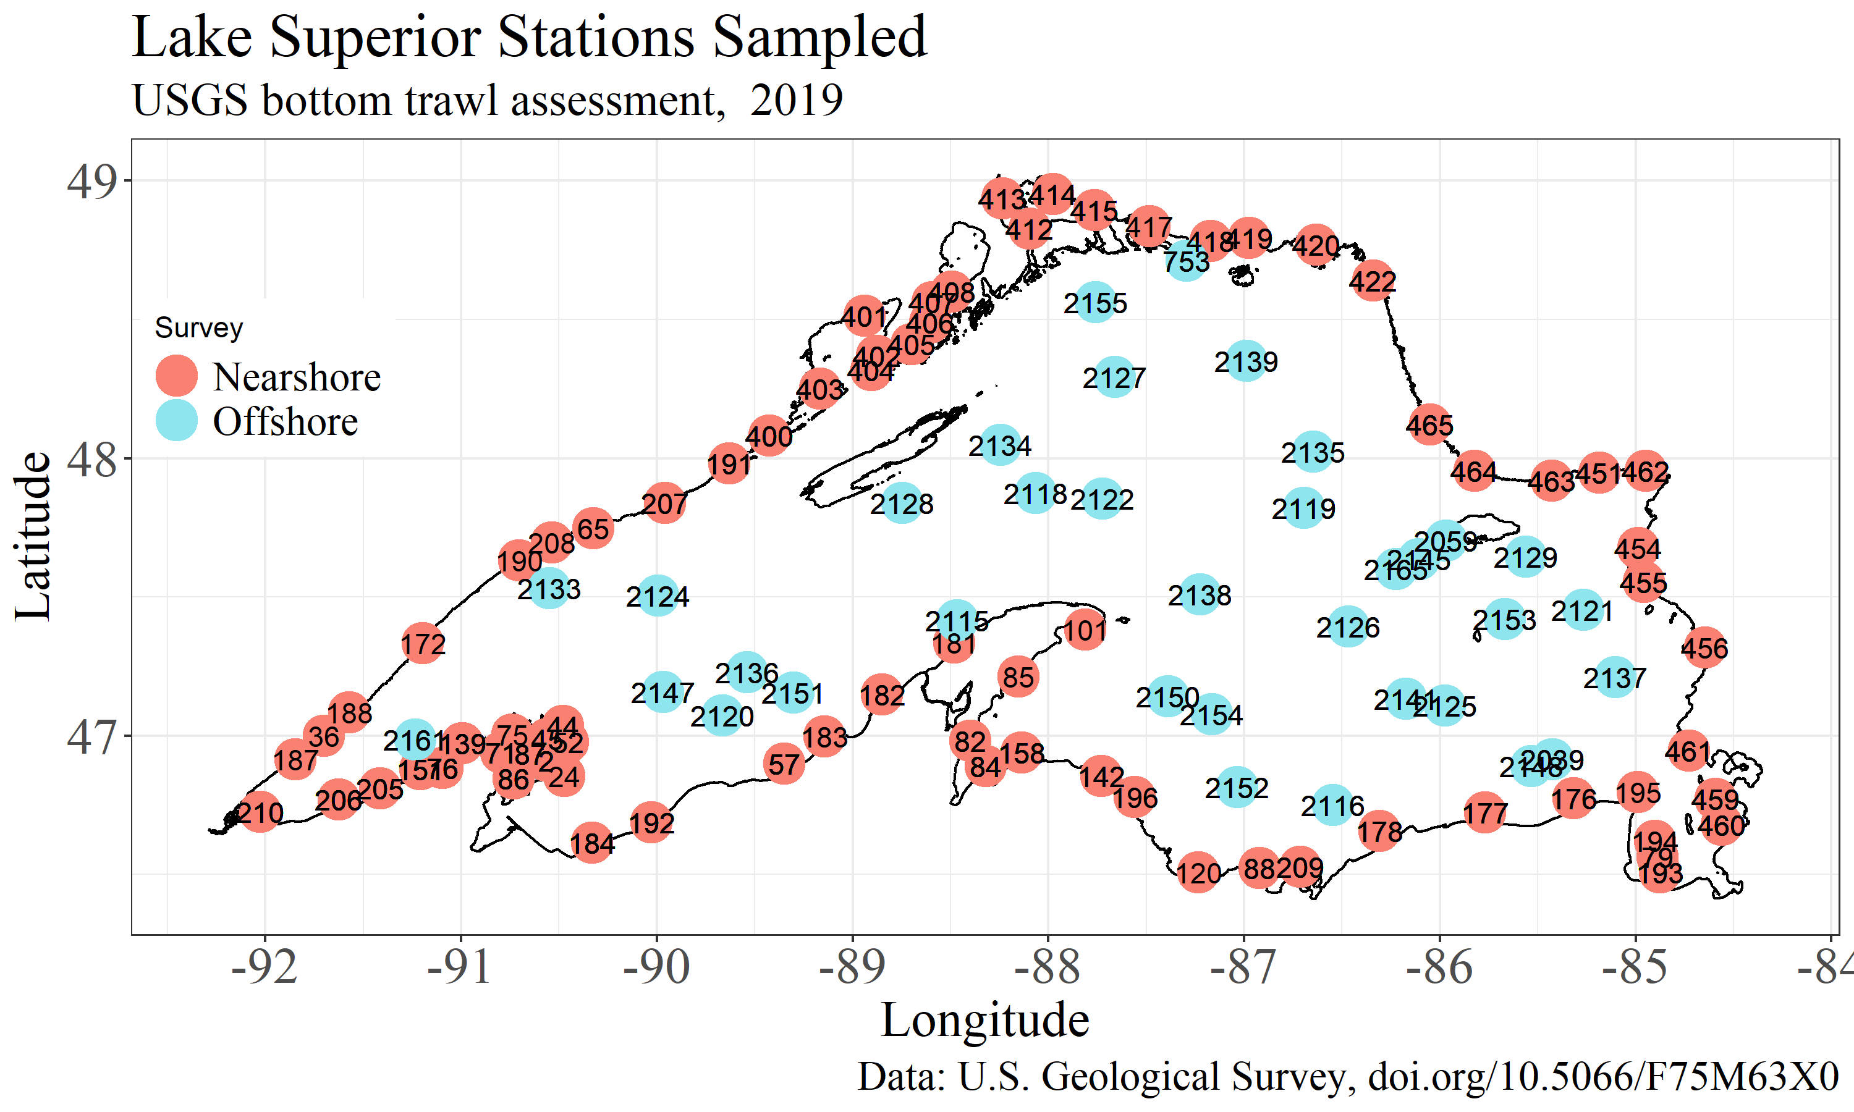 *Figure 1.* Location of 76 nearshore (orange) and 35 offshore (aqua) stations sampled May-July 2019. Samples collected at each location included bottom trawls for demersal fish, surface trawls for larval fish, and whole water column (up to 100 m) zooplankton collections, and a water profile that electronically collected data on depth, temperature, specific conductance, pH, dissolved oxygen, chlorophyll a, photosynthetic active radiation, and beam transmission.

**Offshore survey bottom trawling**

Offshore sites were selected using a spatially-balanced, depth-weighted probabilistic sampling design that targets depths >90 m (Figure 1). Sample sites were selected in 2011 and these same sites have been sampled annually thereafter. In 2019, 35 locations were sampled during daylight hours from **11-25 July**. A single bottom trawl tow was conducted at each site using a 12-m Yankee bottom trawl with a 6-inch rubber roller foot rope. All tows were made on-contour for 20 minutes. Station depths ranged from 88 to 300 m. The median trawl distance was 0.8 km (range 0.8-1 km). The median trawl wing spread was **11.1 m (range 9.7-12.4 m)**. Catches were processed similarly to that described for nearshore trawls. Biomass estimates are presented for Kiyi, Deepwater Sculpin, and siscowet Lake Trout. Year-class recruitment strength was estimated for Kiyi as the mean lakewide density of Kiyi <130 mm collected at offshore stations.

**Results**

**Nearshore survey**

Nearshore water temperatures in 2019 were **similar to** the ten-year average (Figure 2a). Nearshore water temperatures in June averaged 7.2 C (range = 2.5-16.9 C) at the surface and 3.8 C (range = 2.6-4.8 C) at 50 m. The past ten-year average (2010-2019) water temperatures for these same locations and dates were 7.5 C (range=2-19 C) at the surface and 3.9 C (range = 1.8-6.6 C) at 50 m.

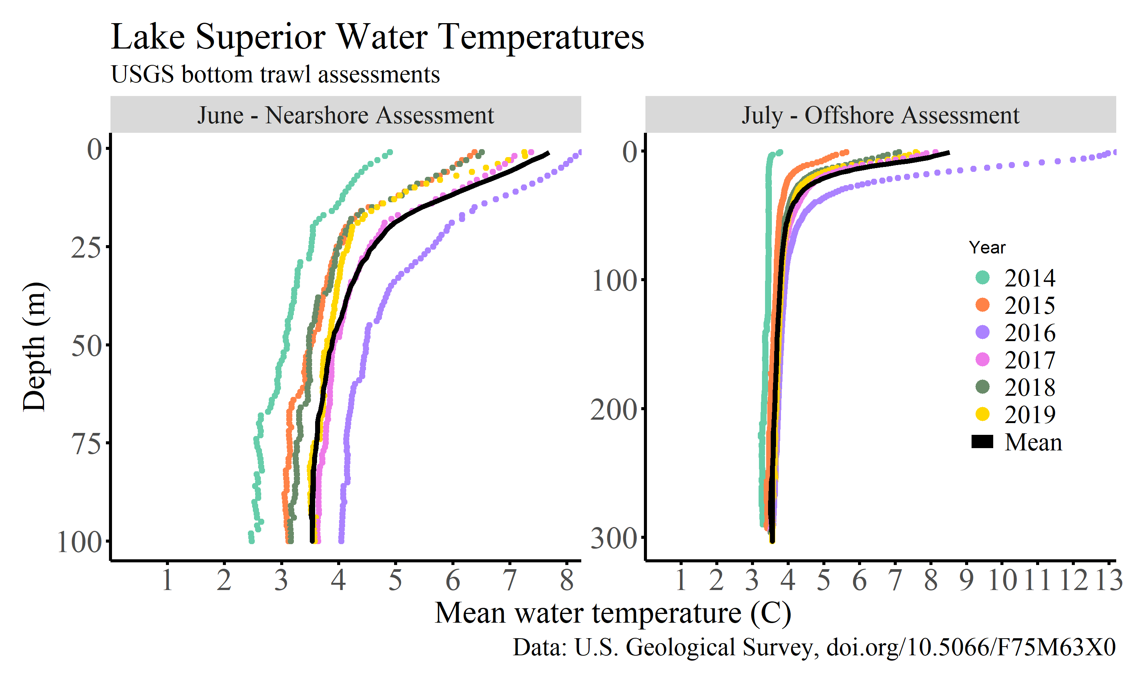 *Figure 2.* Left) Average water temperature profiles across sites sampled during the June-Nearshore and (right) July-Offshore fish community assessments. The solid black line is the mean temperature over the previous ten years for the nearshore assessment and the previous eight years for the offshore assessment (2011-2019, excluding 2012 when no sampling was done in July).

A total of 25146 fish from 24 species or morphotypes were collected at nearshore locations (Table 1). The number of species collected at each station ranged from 0 to 15, with a mean of 5.6 and median of 5. Estimated fish biomass at individual stations ranged from zero to 48.3 kg/ha (Figure 3). The distribution of biomass estimated for all sampling locations was non-normally distributed (Figure 3) as is always the case for this survey. The skewness of the distribution of individual station biomass estimates in 2019 was 2.2 which was less than the period-of-record average skewness of 3.6. Individual stations with the highest biomass were 151-NE Herbster (Bark Point), 71-Raspberry Island, 408-N.E. Black Bay, 45-Cat Island, 86-Basswood Island. Lakewide average nearshore fish biomass was 5.7 kg/ha, which was below the the 42-year period-of-record mean of 8.5 kg/ha (Table 2, Figure 4). In relation to more recent estimates of fish biomass, the 2019 average nearshore biomass estimate was **similar to** the 20-year average of 5.2 kg/ha and greater than the past 10 and 5-year averages of 3.7 and 3.5 kg/ha, respectively (Figure 4).

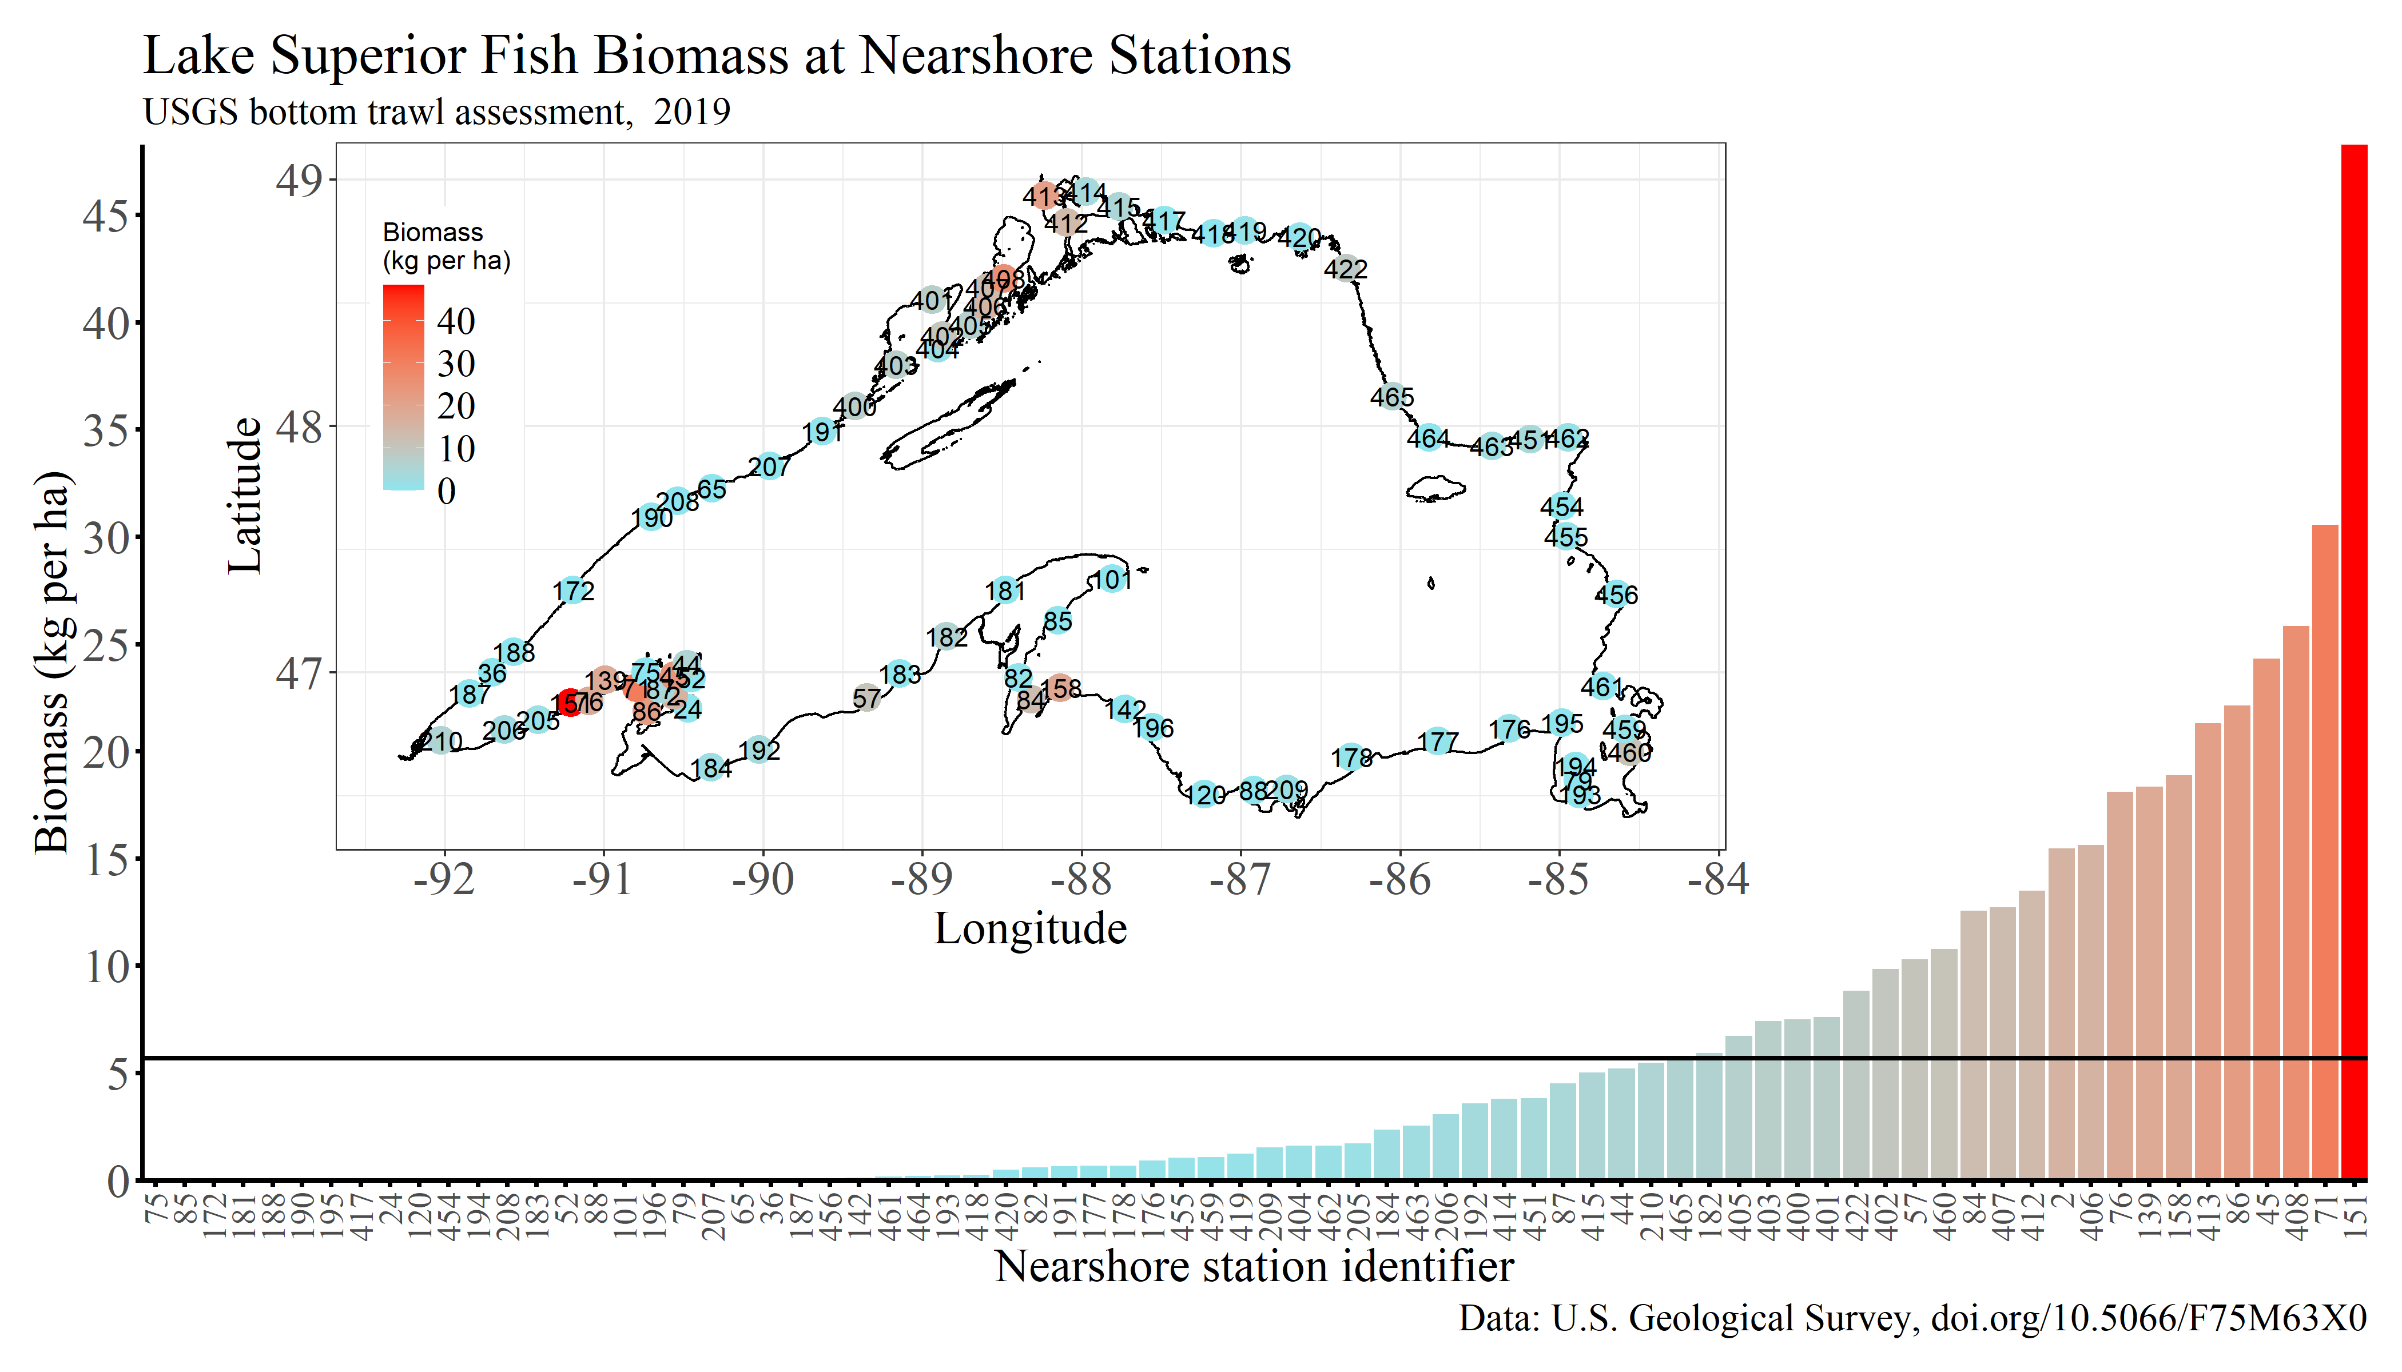 *Figure 3.* Estimated biomass (kg/ha) at individual nearshore sampling stations in 2019. The horizontal like is the 2019 lakewide nearshore average biomass (5.7 kg/ha). The inset figure shows station locations and biomass (kg/ha) in 2019.

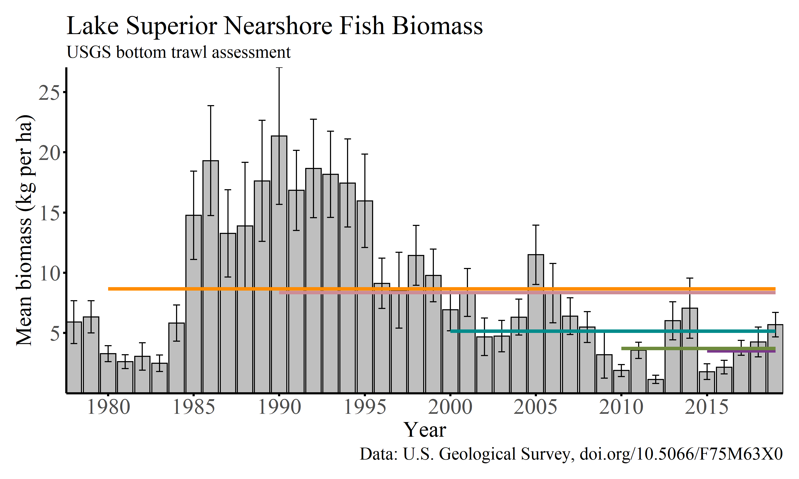 *Figure 4.* Annual nearshore biomass estimates (mean lakewide kg/ha +/- standard error) for all fish species collected in bottom trawls from 1978-2019. Horizontal lines are averages for the previous 5, 10, 20, 30, and 40 years. The number of sites sampled in each year is presented in Table 2.

In 2019, Lake Whitefish, Rainbow Smelt, Longnose Sucker, Bloater, lean Lake Trout, Cisco, Burbot, Pygmy Whitefish had the highest nearshore average biomass. Trends in lakewide nearshore average biomass of individual prey fish species varied among species. Cisco biomass averaged 0.14 kg/ha in 2019. This was generally **similar to** that observed during the prior ten-years and well **below** the period-of-record average of 2.2 kg/ha (Table 2). **Trends in Bloater biomass were similar to that observed for Cisco**. Mean nearshore biomass for Bloater was 0.68 kg/ha in 2019. This was **below** the long-term average of 1.6 kg/ha (Table 2). Conversely, Lake Whitefish biomass in 2019 (2.48 kg/ha) was **similar to** the period-of-record average of 2.1 kg/ha. Likewise, average nearshore biomass of Rainbow Smelt biomass (0.96 kg/ha) in 2019 was **equal to** the period-of-record average of 1.1.

Nearshore Sculpin (Slimy, Spoonhead, and Deepwater) biomass was 0.02 kg/ha in 2019. This was **below** the period-of-record average of 0.1 kg/ha. **Other than the higher estimated densities in 2001 and 2010-11 (~0.05 kg/ha), nearshore sculpin densities have been between 0.01 and 0.03 kg/ha the past twenty years (Table 2). Proportionally, nearshore sculpin biomass has been distributed among sculpin species as ~50% slimy, ~20% Spoonhead, and ~30% Deepwater Sculpin. Over the period-of-record, Slimy Sculpin biomass has declined and Spoonhead and Deepwater Sculpin biomass have increased**.

The combined mean nearshore biomass for all other forage fish species was 0.93 kg/ha in 2019. This was greater than the period-of-record mean of 0.7 kg/ha (Table 2). Miscellaneous species included Ninespine Stickleback, Trout-perch, Kiyi, Shortjaw Cisco, Pygmy Whitefish, Round Whitefish, and Longnose Sucker. Individual species biomass was highest for Longnose Sucker (0.8 kg/ha), Pygmy Whitefish (0.06 kg/ha), and Trout-perch (0.03 kg/ha).

Two piscivorous fish vulnerable to our daytime nearshore bottom trawling are Burbot and juvenile Lake Trout. Burbot nearshore biomass averaged 0.08 kg/ha in 2019, which was **equal to** the period-of-record mean of 0.12 (Table 2). **However, Burbot biomass was roughly twice as high in most years prior to 1996 as compared to the past twenty years.** Hatchery Lake Trout biomass has been near zero since 2000, except for 2005, and the biomass in 2019 was 0.01 kg/ha (Table 2). Lean Lake Trout biomass was 0.33 kg/ha. This was similar to the long-term average of 0.34 kg/ha (Table 2). Siscowet Lake Trout nearshore biomass was 0.05 kg/ha, which was **also equal to** the long-term average of 0.11 (Table 2). Densities of age-3 and younger lean and siscowet Lake Trout were 0.17 and 0.01 fish/ha in 2019, respectively (Table 3), which was **less than** the period-of-record averages for both morphotypes (Table 3).

The density of age-1 prey fish was used as a measure of recruitment. Age-1 Cisco density was 0.3 fish/ha in 2019. Age-1 Cisco were collected at 11 of the 76 nearshore stations sampled (Figure 5). Age-1 Bloater were collected at 17 of the 76 nearshore stations and the average lakewide density was 3.8 fish/ha in 2019 (Figure 5, Table 3). This was **below** the long-term average of 8 fish/ha (Figure 6, Table 3). In contrast to other Coregonus species (Cisco, Bloater, and Kiyi), Lake Whitefish has exhibited more consistent recruitment and lower overall population biomass fluctuations. In 2019, age-1 Lake Whitefish density was 6.7 fish/ha which was **similar to** the long-term average of 6.9 fish/ha (Table 3). Age-1 Rainbow Smelt density was 137.1 fish/ha in 2019, which was similar to the long long-term average of 157 fish/ ha (Table 3).

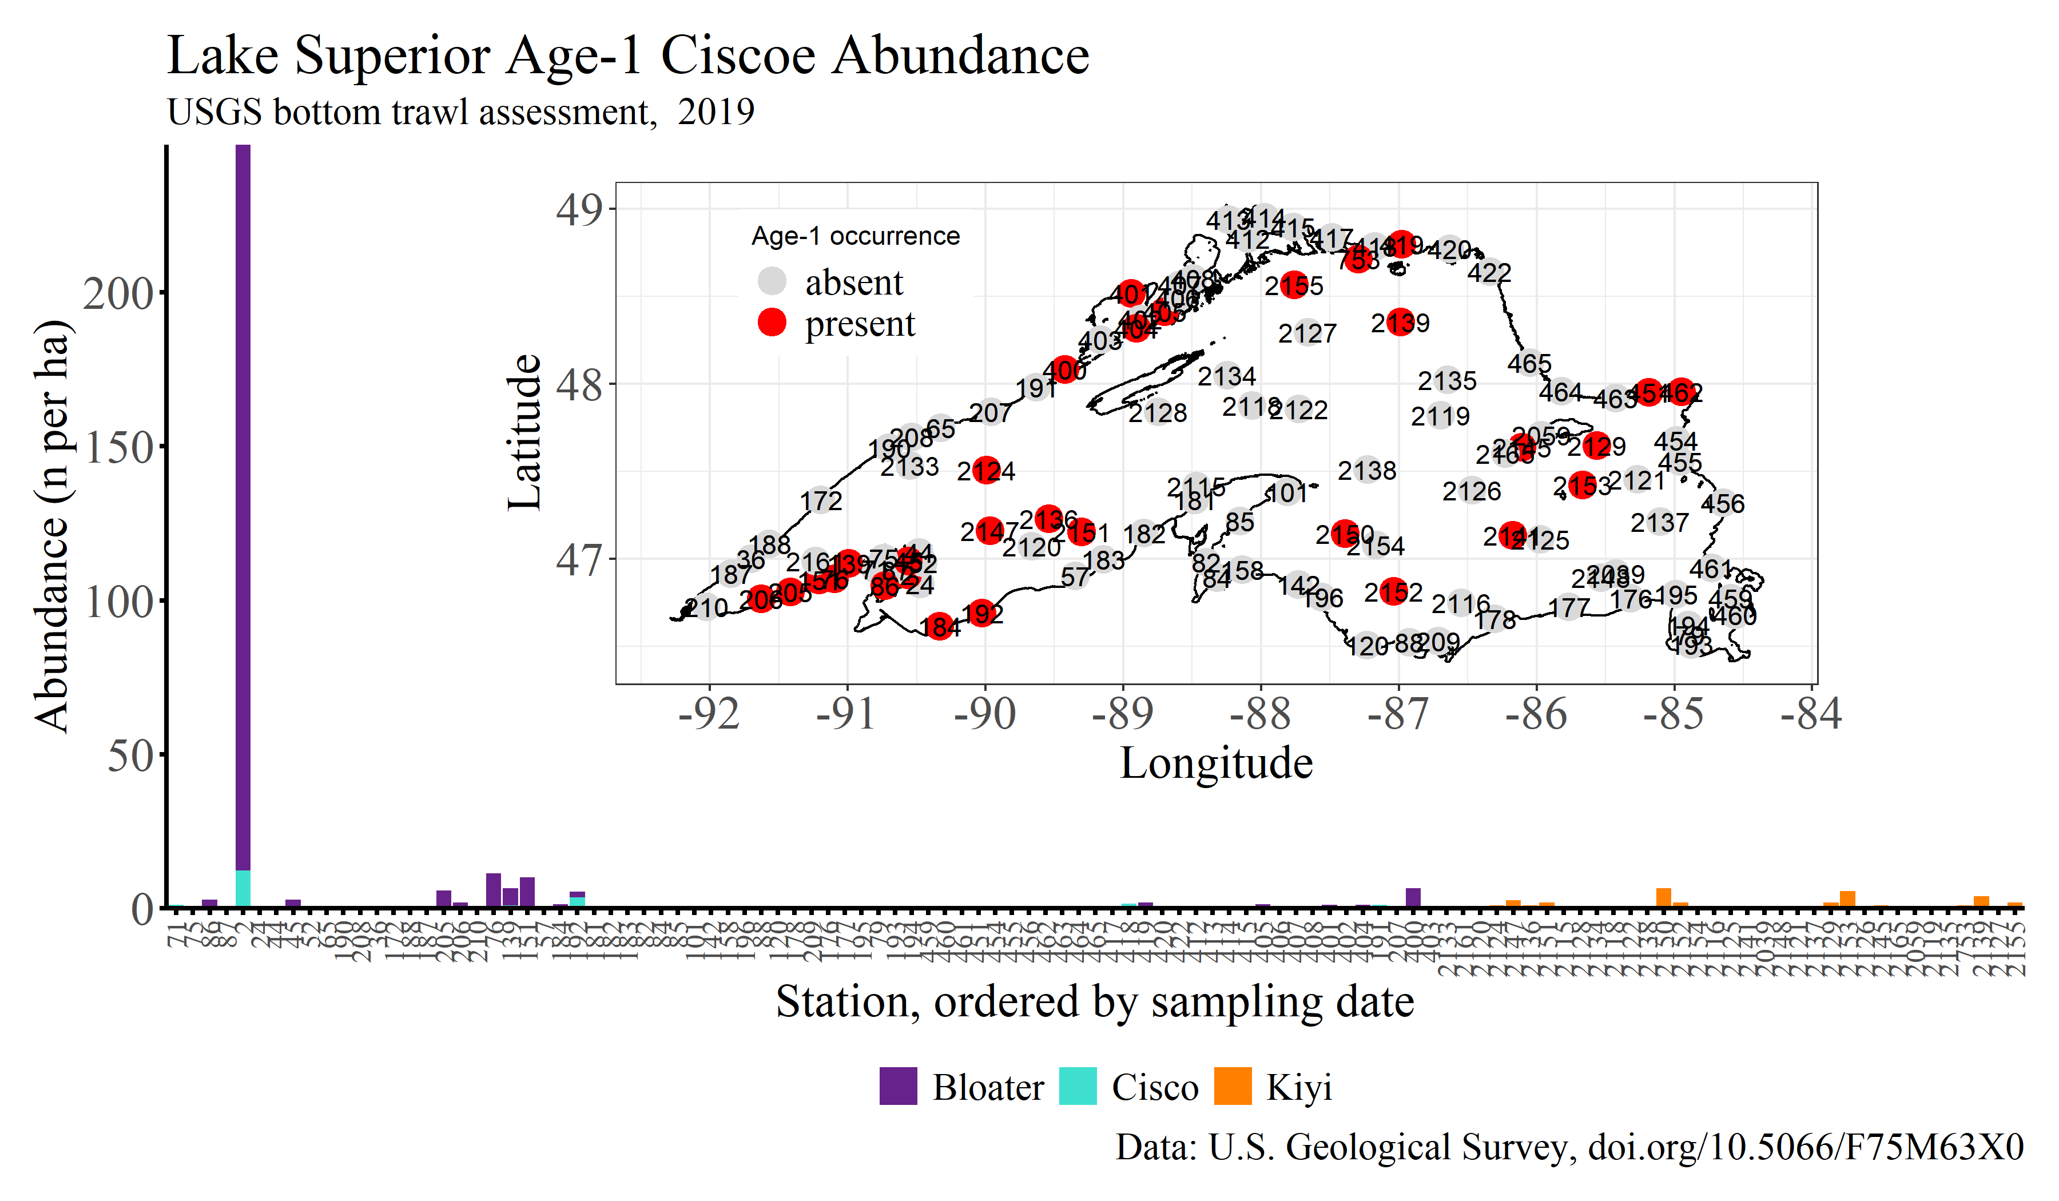 *Figure 5.* Estimated abundance (number/ha) of age-1 Bloater, Cisco, and Kiyi at individual nearshore and offshore sampling stations in 2019. The inset map shows locations where age-1 Bloater, Cisco, and Kiyi were present or absent in 2019.

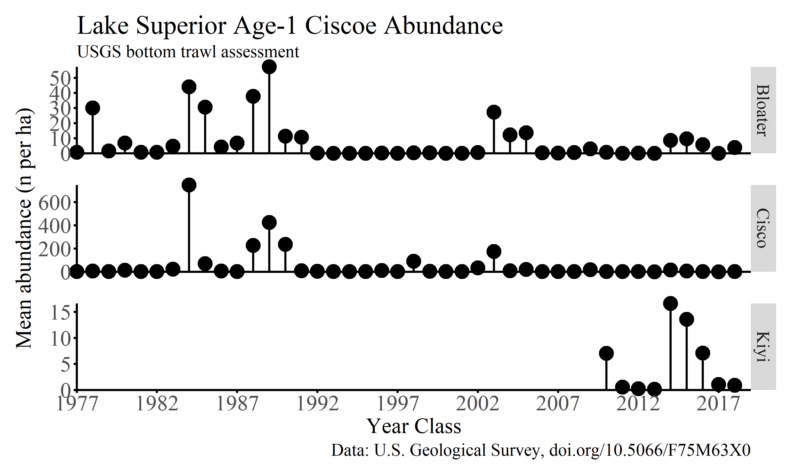 *Figure 6.* Estimated annual average lakewide abundance (number/ha) of age-1 Bloater, Cisco, and Kiyi from 1978-2019. Bloater and Cisco estimates are from nearshore sites and Kiyi estimates are from offshore sampling sites for which sampling began in 2011. Y-axis scales differ among species.

**Offshore survey**

Offshore water temperatures in July were **similar to** the past **eight**-year average (2011-2019, excluding 2012 when sampling was done in August rather than July, Figure 2). Offshore water temperatures in July 2019 averaged 7.5 C (range = 3.8-14.2 C) at the surface and 3.8 C (range = 3.6-4 C) at 100 m (Figure 2). The previous **eight, will calculate 10yr avg once we have more years**-year average water temperatures for these same locations in July were 8.4 C (range=3-18.7 C) at the surface and 3.8 C (range = 2.9-4.7 C) at 100 m.

35 offshore sites were sampled in 2019 from which 13145 fish from 11 species or morphotypes were collected (Table 1). The average and median observed species richness across sites was 3.6 and 4 species, respectively, and ranged from 2 to 6 species. Individual offshore station biomass was non-normally distributed (Figure 7), but the variation in biomass estimates across offshore sites was less than that observed at nearshore locations (Figure 3). The skewness of the distribution of individual station biomass estimates in 2019 was 1.8 which was slightly **greater than** the long-term average skewness of 1.2.

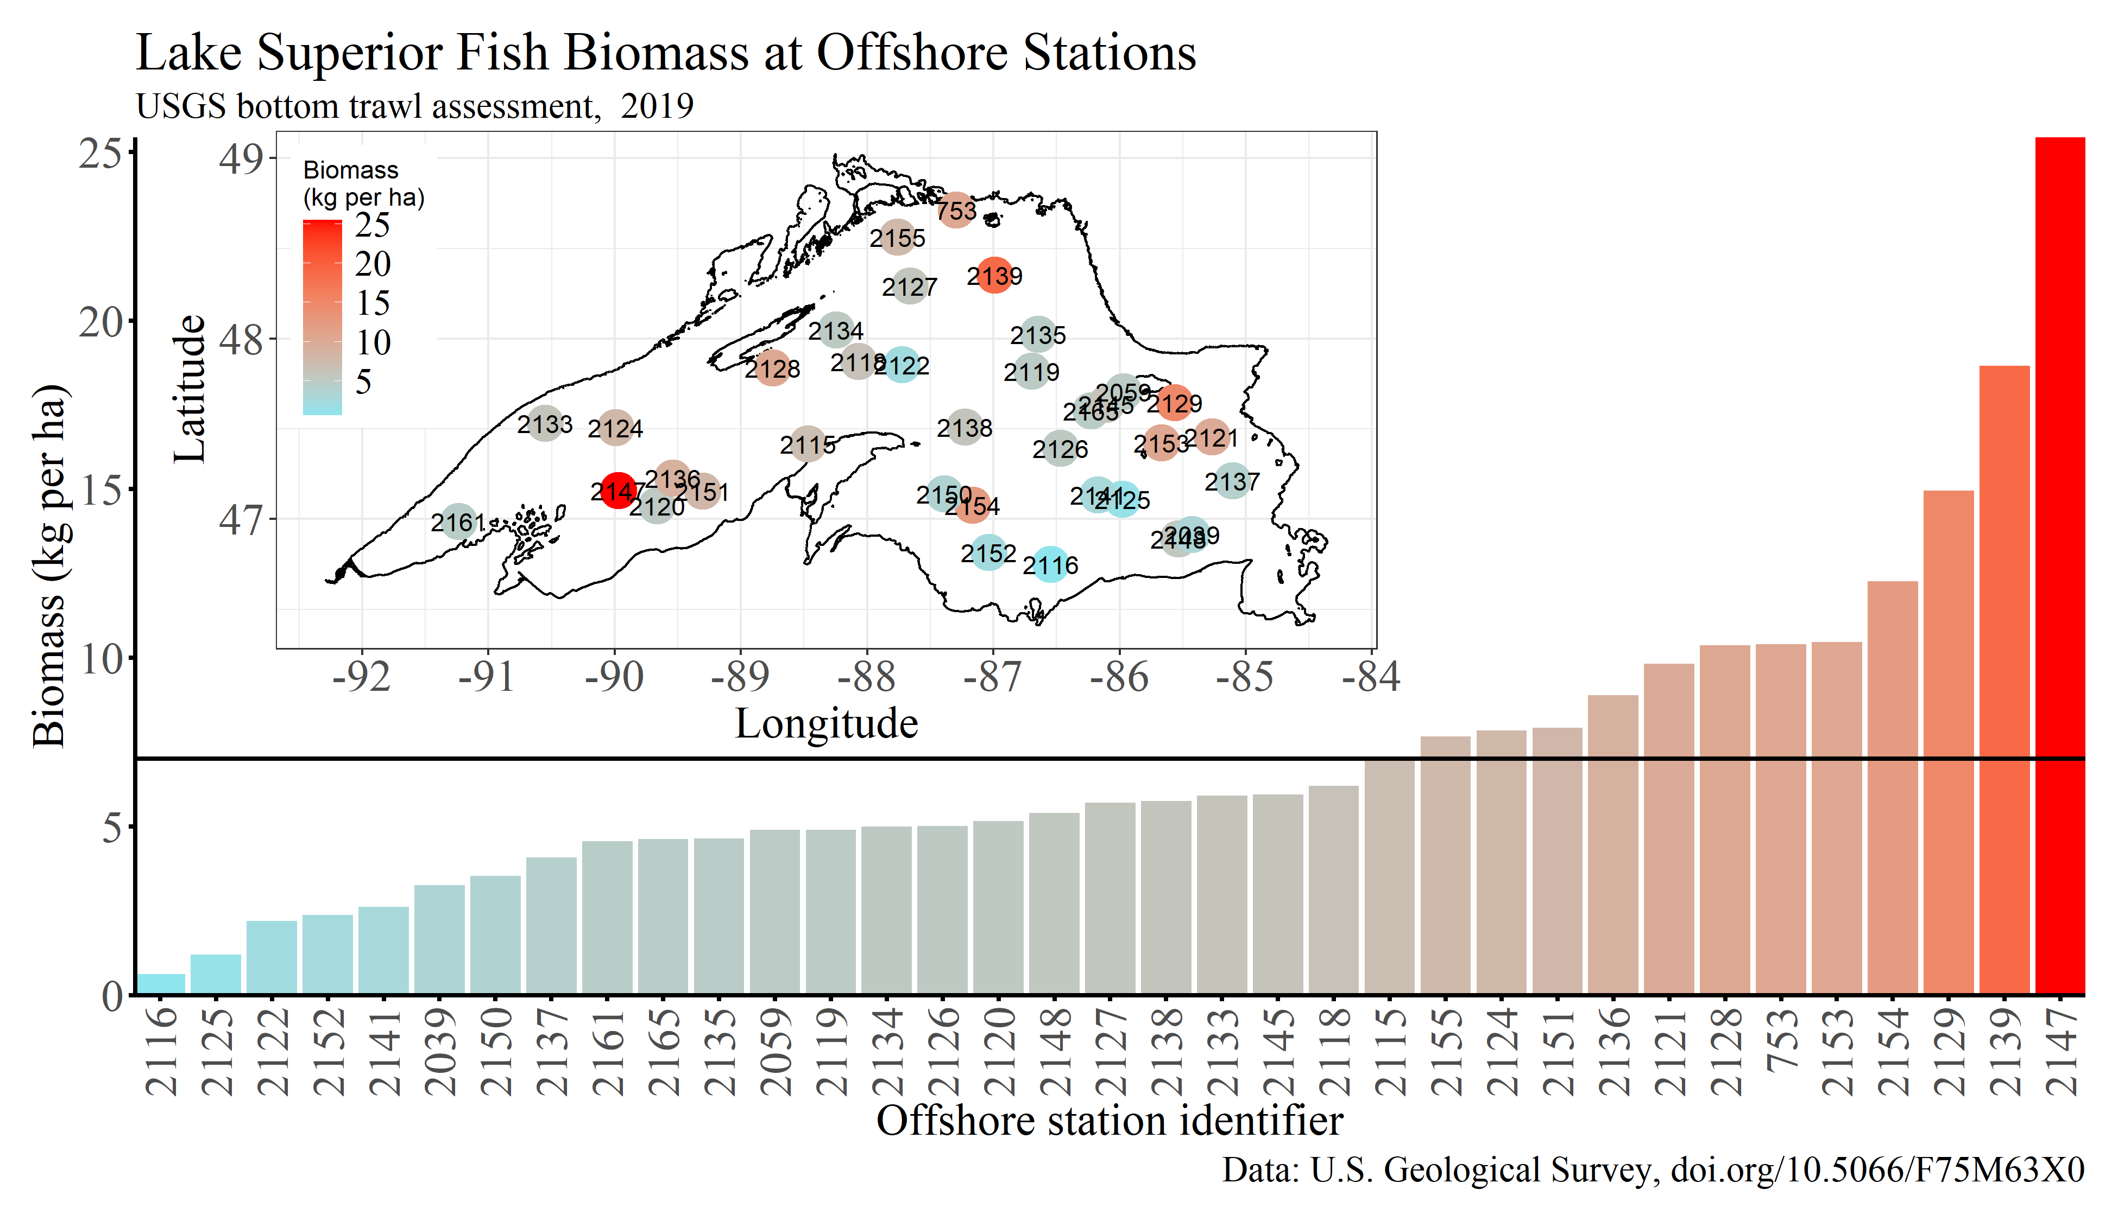 *Figure 7.* Estimated biomass (kg/ha) at individual offshore stations in 2019. The horizontal line is the 2019 lakewide offshore average biomass (7 kg/ha). The inset figure shows station locations and estimated biomass (kg/ha) in 2019.

Deepwater Sculpin, Kiyi, and siscowet Lake Trout made up **99%** of the total number of individuals and biomass collected in offshore waters (Table 1, Figure 8). **Total fish biomass at offshore sites is normally distributed across the sampled depths (90-320 m) and peaks at about 180 m deep (Figure 8). Kiyi biomass was highest from about 140-200 m. Deepwater sculpin biomass was greatest and relatively similar at depths >150 m. Siscowet Lake Trout biomass peaked at about 170-220 m, but can be relatively high at all depths sampled by this survey (90-320 m, Figure 8).**

Deepwater Sculpin offshore biomass averaged 1.7 kg/ha in 2019, which was **slightly less than** the period-of-record mean of 1.9 kg/ha (Figure 9). Kiyi offshore biomass averaged 1.6 kg/ha in 2019 which was **greater than** the period-of-record mean of 1.5 kg/ha (Figure 9). Age-1 Kiyi density at offshore sites was 0.9 fish/ha in 2019 which was **less than** the 2011-2019 average of NA fish/ha (Table 3, Figure 6). Siscowet Lake Trout biomass averaged 3.7 kg/ha in 2019, which was **greater than** the period-of-record mean of 3 kg/ha (Figure 9).

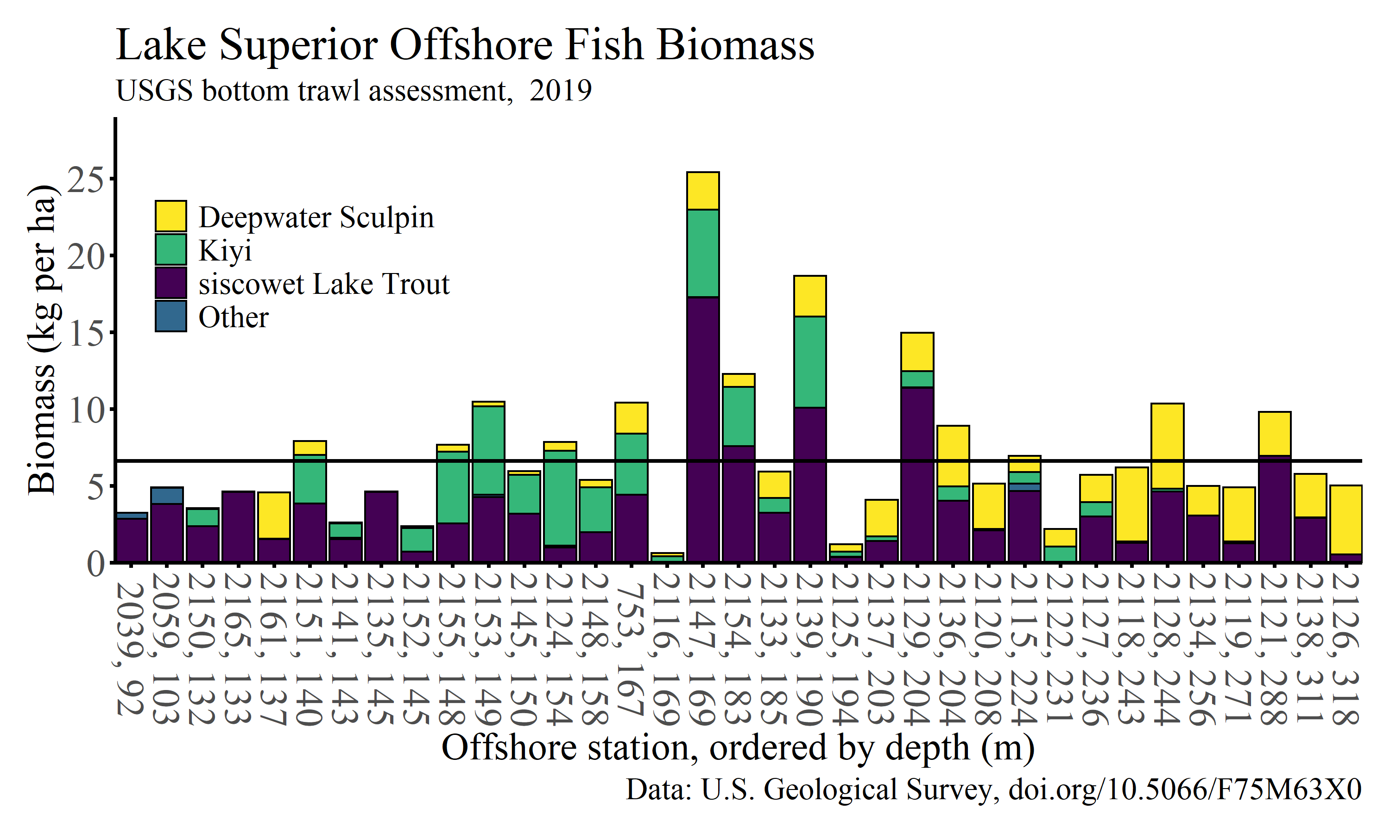 *Figure 8.* Estimated biomass (kg/ha) at individual offshore stations in 2019 for Deepwater Sculpin, Kiyi, siscowet Lake Trout, and other fish. The horizontal line is the average lakewide offshore total biomass in 2019 (7 kg/ha). Bars are ordered by depth from shallowest to deepest.

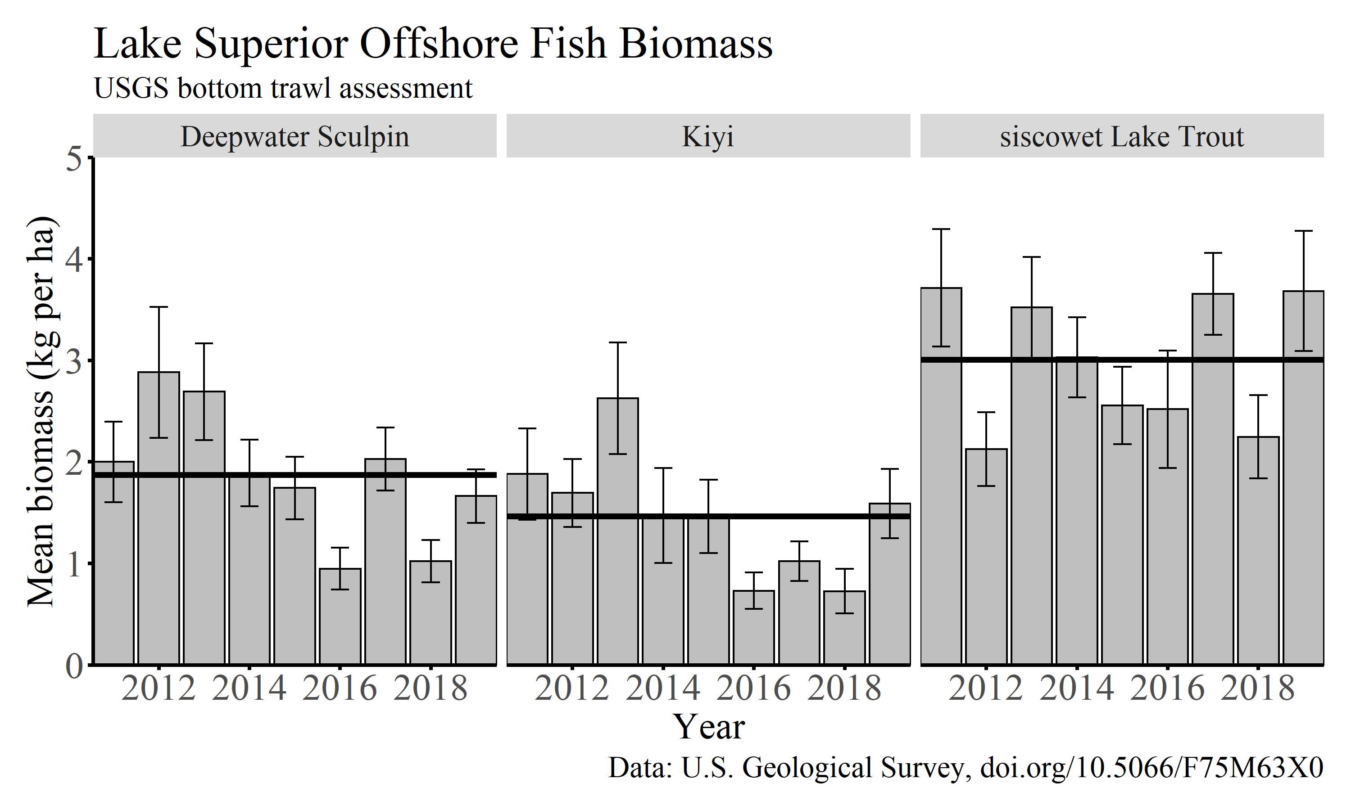 Figure 9. Annual offshore biomass estimates (mean lakewide kg/ha +/- standard error) for Deepwater Sculpin, Kiyi, and siscowet Lake Trout. The horizontal lines are period-of-record (2011-2019) means for each species.

**Summary**

WRITE SOME NEW STUFF EACH YEAR. Biomass trends in other nearshore demersal species have been generally steady over the past five years with some species, such as Lake Whitefish, Ninespine Stickleback, and Longnose Sucker exhibiting increases in biomass over the past 10 -20 years (Figure 10).

The combination of our near- and offshore bottom trawl surveys provide a lakewide picture of the status and trends of the Lake Superior fish community susceptible to bottom trawls, particularly with respect to describing survival of Coregonus species to age-1 and offshore Deepwater Sculpin, Kiyi, and siscowet lake populations. Our plan is to continue these surveys into the future and adapt them as needed to address emerging issues.

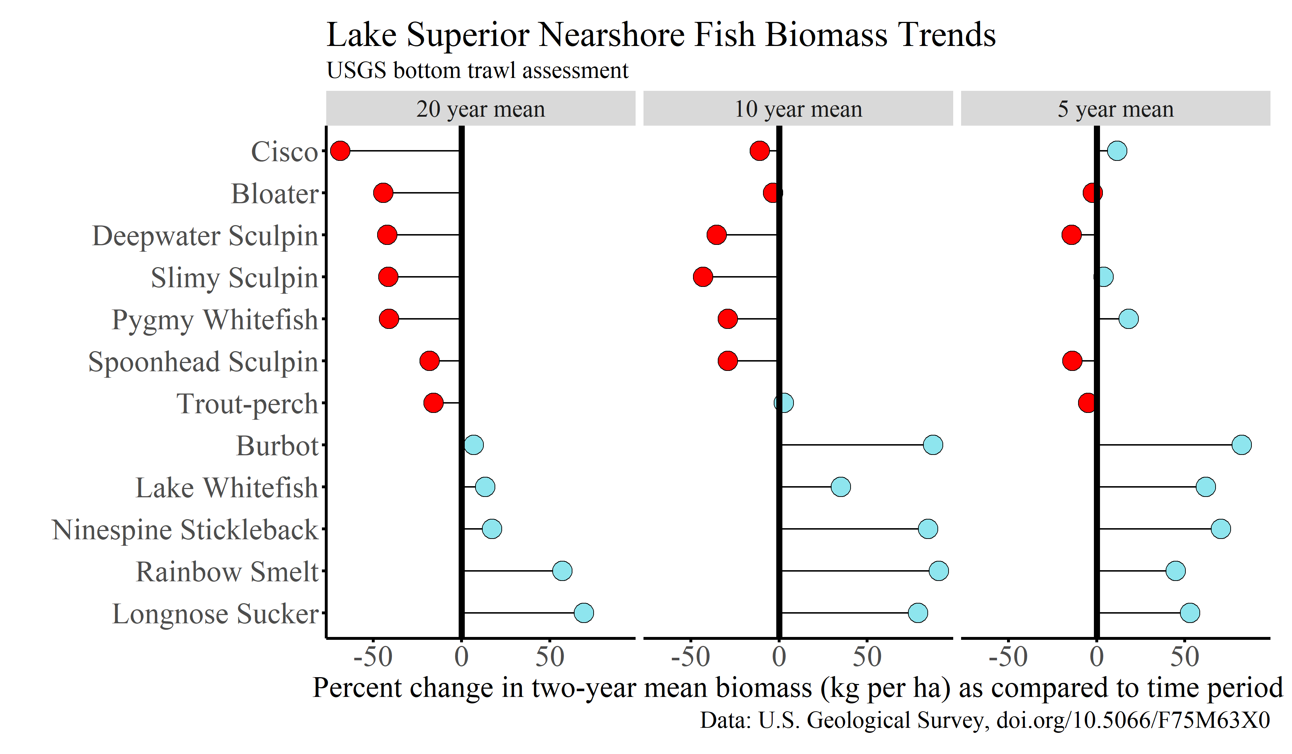 *Figure 10.* Comparison of the average biomass of common nearshore species in 2018-2019 to average biomass estimates for the previous five, ten, and 20-year time periods.

Note: All GLSC sampling and handling of fish during research are carried out in accordance with guidelines for the care and use of fishes by the American Fisheries Society (<http://fisheries.org/docs/wp/Guidelines-for-Use-of-Fishes.pdf>).

*Table 1.* Fish species and the number of individuals collected in nearshore and offshore bottom trawl surveys in Lake Superior in 2019. Sampling locations shown in Figure 1.

|  |  |  |  |
| --- | --- | --- | --- |
| Common name | Scientific name | Nearshore | Offshore |
| Alewife | Alosa pseudoharengus | 10 | 0 |
| Blackfin Cisco | Coregonus nigripinnis | 4 | 0 |
| Bloater | Coregonus hoyi | 1622 | 8 |
| Burbot | Lota lota | 18 | 1 |
| Cisco | Coregonus artedii | 139 | 0 |
| Deepwater Sculpin | Myoxocephalus thompsonii | 32 | 11073 |
| hatchery Lake Trout | Salvelinus namaycush | 10 | 0 |
| Kiyi | Coregonus kiyi | 24 | 1706 |
| Lake Whitefish | Coregonus clupeaformis | 1512 | 0 |
| lean Lake Trout | Salvelinus namaycush | 104 | 2 |
| Longnose Sucker | Catostomus catostomus | 122 | 0 |
| Ninespine Stickleback | Pungitius pungitius | 914 | 1 |
| Pygmy Whitefish | Prosopium coulteri | 878 | 62 |
| Rainbow Smelt | Osmerus mordax | 18542 | 5 |
| Round Whitefish | Prosopium cylindraceum | 3 | 0 |
| Ruffe | Gymnocephalus cernuus | 17 | 0 |
| Shortjaw Cisco | Coregonus zenithicus | 19 | 0 |
| siscowet Lake Trout | Salvelinus namaycush siscowet | 12 | 254 |
| Slimy Sculpin | Cottus cognatus | 345 | 27 |
| Spoonhead Sculpin | Cottus ricei | 104 | 6 |
| Spottail Shiner | Notropis hudsonius | 3 | 0 |
| Threespine Stickleback | Gasterosteus aculeatus | 2 | 0 |
| Trout-perch | Percopsis omiscomaycus | 693 | 0 |
| Yellow Perch | Perca flavescens | 2 | 0 |

*Table 2.* Mean annual Lake Superior nearshore bottom trawl biomass (kg/ha) estimates for common fishes. Sculpin includes Slimy, Spoonhead, and Deepwater sculpin. Mean and median total biomass includes all species. Miscellaneous species includes Ninespine Stickleback, Trout-Perch, Kiyi, Shortjaw Cisco, Pygmy Whitefish, Round Whitefish, and Longnose Sucker. No fish sites are the number of locations where no fish were collected.

|  |  |  |  |  |  |  |  |  |  |  |  |  |  |  |  |
| --- | --- | --- | --- | --- | --- | --- | --- | --- | --- | --- | --- | --- | --- | --- | --- |
| Year | Sites | No fish sites | Total species collected | Total biomass | Median biomass | Rainbow Smelt | Cisco | Lake Whitefish | Bloater | hatchery Lake Trout | lean Lake Trout | siscowet Lake Trout | Burbot | Sculpins | Misc Spp |
| 1978 | 43 | 0 | 17 | 5.9 | 0.8 | 4.1 | 0.0 | 0.7 | 0.1 | 0.4 | 0.0 | 0.0 | 0.2 | 0.1 | 0.3 |
| 1979 | 49 | 0 | 17 | 6.3 | 2.2 | 2.2 | 0.1 | 1.3 | 0.4 | 0.7 | 0.1 | 0.0 | 0.3 | 0.2 | 1.1 |
| 1980 | 48 | 0 | 16 | 3.3 | 1.1 | 0.9 | 0.3 | 0.6 | 0.3 | 0.5 | 0.0 | 0.0 | 0.2 | 0.2 | 0.4 |
| 1981 | 48 | 2 | 18 | 2.6 | 0.4 | 0.2 | 0.4 | 0.7 | 0.4 | 0.3 | 0.0 | 0.0 | 0.2 | 0.2 | 0.2 |
| 1982 | 32 | 0 | 17 | 3.1 | 0.3 | 0.2 | 0.4 | 0.8 | 0.4 | 0.7 | 0.1 | 0.0 | 0.1 | 0.0 | 0.3 |
| 1983 | 50 | 0 | 18 | 2.5 | 0.5 | 0.9 | 0.2 | 0.2 | 0.4 | 0.4 | 0.0 | 0.0 | 0.1 | 0.1 | 0.2 |
| 1984 | 53 | 0 | 21 | 5.8 | 1.7 | 0.8 | 0.6 | 1.3 | 1.8 | 0.5 | 0.3 | 0.0 | 0.2 | 0.1 | 0.2 |
| 1985 | 53 | 0 | 19 | 14.8 | 3.5 | 1.3 | 6.5 | 2.1 | 2.7 | 0.4 | 0.8 | 0.0 | 0.0 | 0.1 | 0.8 |
| 1986 | 53 | 2 | 19 | 19.3 | 4.0 | 2.8 | 8.7 | 2.6 | 3.8 | 0.3 | 0.6 | 0.1 | 0.2 | 0.1 | 0.2 |
| 1987 | 53 | 0 | 16 | 13.3 | 1.4 | 1.8 | 5.7 | 2.0 | 2.6 | 0.2 | 0.3 | 0.0 | 0.1 | 0.1 | 0.4 |
| 1988 | 53 | 0 | 19 | 13.9 | 0.9 | 1.2 | 3.1 | 2.4 | 6.0 | 0.2 | 0.8 | 0.0 | 0.1 | 0.0 | 0.2 |
| 1989 | 76 | 0 | 21 | 17.6 | 3.4 | 2.1 | 6.2 | 5.5 | 1.7 | 0.2 | 0.5 | 0.2 | 0.2 | 0.1 | 0.9 |
| 1990 | 81 | 0 | 22 | 21.4 | 5.4 | 2.0 | 10.1 | 2.4 | 4.8 | 0.1 | 0.3 | 0.2 | 0.1 | 0.1 | 1.2 |
| 1991 | 84 | 1 | 22 | 16.8 | 3.6 | 1.2 | 10.2 | 2.7 | 0.8 | 0.1 | 0.7 | 0.0 | 0.2 | 0.1 | 0.8 |
| 1992 | 85 | 0 | 24 | 18.7 | 3.3 | 1.0 | 3.4 | 3.7 | 8.4 | 0.2 | 0.6 | 0.0 | 0.2 | 0.1 | 1.1 |
| 1993 | 87 | 1 | 23 | 18.2 | 6.0 | 2.1 | 5.0 | 3.7 | 4.3 | 0.3 | 0.6 | 0.1 | 0.3 | 0.1 | 1.7 |
| 1994 | 87 | 0 | 23 | 17.5 | 3.6 | 1.9 | 7.2 | 5.4 | 0.4 | 0.2 | 0.6 | 0.1 | 0.1 | 0.1 | 1.3 |
| 1995 | 87 | 0 | 27 | 16.0 | 3.0 | 2.2 | 4.0 | 5.8 | 0.6 | 0.2 | 0.9 | 0.1 | 0.1 | 0.1 | 1.9 |
| 1996 | 87 | 0 | 26 | 9.1 | 2.5 | 1.3 | 1.0 | 1.6 | 3.1 | 0.2 | 0.5 | 0.4 | 0.2 | 0.1 | 0.7 |
| 1997 | 85 | 1 | 30 | 8.6 | 2.2 | 1.4 | 1.4 | 2.8 | 0.9 | 0.2 | 0.7 | 0.3 | 0.1 | 0.1 | 0.8 |
| 1998 | 87 | 0 | 22 | 11.4 | 2.0 | 1.5 | 1.1 | 2.3 | 4.4 | 0.1 | 0.6 | 0.2 | 0.1 | 0.1 | 1.1 |
| 1999 | 83 | 5 | 23 | 9.8 | 1.7 | 1.1 | 2.7 | 1.3 | 3.1 | 0.0 | 0.4 | 0.2 | 0.1 | 0.0 | 0.8 |
| 2000 | 85 | 4 | 25 | 6.9 | 1.1 | 0.8 | 2.4 | 1.6 | 0.9 | 0.0 | 0.3 | 0.2 | 0.0 | 0.0 | 0.6 |
| 2001 | 83 | 1 | 32 | 8.4 | 1.7 | 1.5 | 1.1 | 2.8 | 1.2 | 0.0 | 0.6 | 0.1 | 0.1 | 0.0 | 0.6 |
| 2002 | 84 | 2 | 26 | 4.7 | 0.5 | 0.2 | 1.5 | 1.7 | 0.6 | 0.0 | 0.2 | 0.0 | 0.1 | 0.0 | 0.4 |
| 2003 | 86 | 8 | 26 | 4.8 | 1.0 | 0.3 | 0.6 | 1.8 | 0.9 | 0.0 | 0.3 | 0.2 | 0.0 | 0.0 | 0.4 |
| 2004 | 75 | 1 | 25 | 6.3 | 1.9 | 0.3 | 1.8 | 1.9 | 1.1 | 0.0 | 0.1 | 0.2 | 0.2 | 0.0 | 0.6 |
| 2005 | 51 | 0 | 27 | 11.5 | 4.5 | 0.9 | 2.3 | 4.5 | 1.7 | 0.2 | 0.6 | 0.0 | 0.3 | 0.0 | 0.5 |
| 2006 | 55 | 2 | 24 | 8.3 | 1.6 | 1.0 | 2.2 | 1.7 | 1.8 | 0.0 | 0.3 | 0.1 | 0.1 | 0.0 | 1.0 |
| 2007 | 54 | 0 | 31 | 6.4 | 1.1 | 1.8 | 0.3 | 1.9 | 0.9 | 0.0 | 0.2 | 0.1 | 0.1 | 0.0 | 0.9 |
| 2008 | 58 | 3 | 23 | 5.5 | 1.6 | 1.0 | 0.4 | 2.4 | 0.2 | 0.1 | 0.2 | 0.1 | 0.3 | 0.0 | 0.8 |
| 2009 | 63 | 6 | 20 | 3.2 | 0.2 | 0.4 | 0.3 | 0.2 | 1.2 | 0.0 | 0.2 | 0.1 | 0.0 | 0.0 | 0.7 |
| 2010 | 62 | 7 | 24 | 1.9 | 0.2 | 0.2 | 0.4 | 0.2 | 0.2 | 0.0 | 0.0 | 0.1 | 0.0 | 0.0 | 0.3 |
| 2011 | 82 | 6 | 21 | 3.6 | 1.3 | 0.6 | 0.4 | 0.9 | 0.6 | 0.0 | 0.1 | 0.1 | 0.0 | 0.0 | 0.7 |
| 2012 | 72 | 16 | 25 | 1.1 | 0.3 | 0.2 | 0.0 | 0.2 | 0.4 | 0.0 | 0.1 | 0.1 | 0.0 | 0.0 | 0.3 |
| 2013 | 79 | 3 | 27 | 6.0 | 1.2 | 0.5 | 0.5 | 3.0 | 0.5 | 0.0 | 0.3 | 0.3 | 0.1 | 0.0 | 0.8 |
| 2014 | 73 | 3 | 28 | 7.1 | 1.9 | 0.4 | 0.4 | 4.3 | 0.5 | 0.0 | 0.4 | 0.3 | 0.1 | 0.0 | 0.7 |
| 2015 | 76 | 4 | 21 | 1.8 | 0.2 | 0.2 | 0.2 | 0.5 | 0.4 | 0.0 | 0.1 | 0.1 | 0.0 | 0.0 | 0.2 |
| 2016 | 76 | 5 | 23 | 2.2 | 0.2 | 0.4 | 0.2 | 0.5 | 0.4 | 0.0 | 0.1 | 0.1 | 0.0 | 0.0 | 0.3 |
| 2017 | 76 | 4 | 27 | 3.8 | 1.8 | 0.9 | 0.2 | 1.1 | 0.5 | 0.0 | 0.2 | 0.1 | 0.0 | 0.0 | 0.7 |
| 2018 | 77 | 10 | 24 | 4.3 | 0.3 | 1.2 | 0.4 | 1.5 | 0.1 | 0.0 | 0.2 | 0.1 | 0.1 | 0.0 | 0.6 |
| 2019 | 76 | 8 | 25 | 5.7 | 1.4 | 1.0 | 0.1 | 2.5 | 0.7 | 0.0 | 0.3 | 0.0 | 0.1 | 0.0 | 0.9 |

*Table 3.* Mean annual Lake Superior bottom trawl age-1 density (number/ha) estimates for nearshore collected Cisco, Bloater, Lake Whitefish, and Rainbow Smelt, offshore collected Kiyi, and nearshore small lean and siscowet Lake Trout (<age-3). Age-1 fish were defined by species-specific lengths: Cisco <140 mm, Bloater <130 mm, Lake Whitefish <160 mm, Rainbow Smelt <100 mm, and Kiyi <130 mm. Lean and siscowet Lake Trout data are for fish <226 mm (~< age 3).

|  |  |  |  |  |  |  |  |  |
| --- | --- | --- | --- | --- | --- | --- | --- | --- |
| Year | Year Class | Rainbow Smelt | Cisco | Bloater | Lake Whitefish | Kiyi | lean Lake Trout | siscowet Lake Trout |
| 1978 | 1977 | 95.8 | 0.0 | 0.8 | 2.6 | NA | 0.2 | 0.0 |
| 1979 | 1978 | 234.1 | 6.3 | 30.1 | 3.9 | NA | 0.4 | 0.0 |
| 1980 | 1979 | 96.8 | 0.1 | 1.6 | 2.0 | NA | 0.2 | 0.0 |
| 1981 | 1980 | 106.3 | 13.5 | 6.8 | 16.4 | NA | 0.6 | 0.1 |
| 1982 | 1981 | 63.8 | 0.2 | 0.8 | 4.2 | NA | 0.4 | 0.0 |
| 1983 | 1982 | 103.6 | 0.0 | 0.8 | 0.4 | NA | 0.4 | 0.0 |
| 1984 | 1983 | 223.7 | 21.8 | 4.7 | 8.0 | NA | 1.2 | 0.0 |
| 1985 | 1984 | 149.5 | 748.0 | 44.0 | 2.5 | NA | 1.3 | 0.0 |
| 1986 | 1985 | 150.4 | 68.9 | 30.6 | 3.5 | NA | 0.9 | 0.1 |
| 1987 | 1986 | 273.8 | 5.4 | 4.2 | 11.9 | NA | 0.7 | 0.0 |
| 1988 | 1987 | 155.3 | 0.5 | 6.9 | 6.1 | NA | 0.5 | 0.0 |
| 1989 | 1988 | 274.8 | 226.8 | 37.7 | 36.1 | NA | 0.3 | 0.1 |
| 1990 | 1989 | 269.5 | 425.6 | 57.3 | 8.8 | NA | 0.4 | 0.0 |
| 1991 | 1990 | 162.0 | 236.9 | 11.4 | 17.5 | NA | 0.7 | 0.0 |
| 1992 | 1991 | 176.8 | 9.1 | 10.7 | 11.8 | NA | 0.8 | 0.0 |
| 1993 | 1992 | 155.2 | 3.3 | 0.2 | 7.7 | NA | 0.8 | 0.2 |
| 1994 | 1993 | 198.6 | 0.8 | 0.1 | 5.0 | NA | 1.1 | 0.0 |
| 1995 | 1994 | 401.8 | 1.5 | 0.0 | 13.5 | NA | 1.7 | 0.0 |
| 1996 | 1995 | 168.2 | 1.0 | 0.0 | 6.3 | NA | 2.3 | 0.2 |
| 1997 | 1996 | 253.0 | 11.1 | 0.2 | 8.8 | NA | 0.8 | 0.1 |
| 1998 | 1997 | 145.0 | 1.2 | 0.1 | 7.7 | NA | 1.2 | 0.0 |
| 1999 | 1998 | 216.2 | 90.6 | 0.4 | 9.2 | NA | 0.3 | 0.1 |
| 2000 | 1999 | 58.4 | 3.8 | 0.5 | 0.8 | NA | 0.4 | 0.0 |
| 2001 | 2000 | 257.4 | 0.8 | 0.1 | 2.4 | NA | 0.5 | 0.0 |
| 2002 | 2001 | 56.8 | 0.5 | 0.1 | 13.7 | NA | 0.2 | 0.1 |
| 2003 | 2002 | 77.9 | 33.2 | 0.6 | 7.8 | NA | 0.2 | 0.0 |
| 2004 | 2003 | 70.3 | 175.3 | 27.3 | 6.4 | NA | 0.2 | 0.0 |
| 2005 | 2004 | 111.0 | 8.3 | 12.3 | 3.0 | NA | 0.6 | 0.1 |
| 2006 | 2005 | 249.5 | 18.6 | 13.6 | 5.4 | NA | 0.4 | 0.2 |
| 2007 | 2006 | 377.6 | 0.4 | 0.3 | 20.5 | NA | 0.1 | 0.1 |
| 2008 | 2007 | 284.5 | 0.2 | 0.3 | 0.6 | NA | 0.2 | 0.1 |
| 2009 | 2008 | 72.2 | 0.3 | 0.6 | 3.0 | NA | 0.1 | 0.1 |
| 2010 | 2009 | 47.2 | 16.5 | 3.0 | 8.1 | NA | 0.0 | 0.1 |
| 2011 | 2010 | 74.0 | 0.3 | 0.8 | 4.0 | 7.0 | 0.4 | 0.0 |
| 2012 | 2011 | 10.9 | 0.0 | 0.1 | 1.9 | 0.6 | 0.4 | 0.1 |
| 2013 | 2012 | 142.9 | 0.2 | 0.2 | 5.5 | 0.2 | 0.4 | 0.1 |
| 2014 | 2013 | 68.5 | 0.0 | 0.1 | 2.3 | 0.1 | 0.3 | 0.1 |
| 2015 | 2014 | 30.7 | 14.3 | 8.6 | 1.0 | 16.6 | 0.1 | 0.1 |
| 2016 | 2015 | 83.0 | 5.0 | 9.7 | 1.6 | 13.6 | 0.4 | 0.1 |
| 2017 | 2016 | 146.9 | 1.4 | 5.8 | 1.4 | 7.1 | 0.8 | 0.0 |
| 2018 | 2017 | 161.4 | 0.0 | 0.1 | 1.1 | 1.1 | 0.1 | 0.0 |
| 2019 | 2018 | 137.1 | 0.3 | 3.8 | 6.7 | 0.9 | 0.2 | 0.0 |

## ##------ Wed Apr 08 12:35:26 2020 ------##